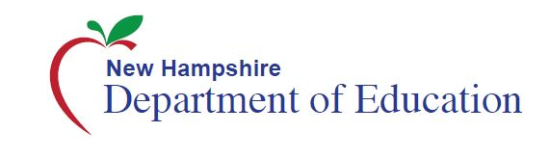

Talking Points ~ Assessment Results

- We are committed to preparing all students for success at each grade and after high school.

- We know that whether students want to go to college, the military or straight into the workplace, our students need to be able to think critically and solve complex problems. Ensuring that our students have these tools empowers parents and students because it gives them the ability to make choices about their future and make the most of their opportunities.

- The student results on the statewide Smarter Balanced Assessment establish a new baseline that enables all of us to know where students stand on their path to success and measure progress going forward.

- The Smarter Balanced results provide teachers and parents with information about where students are doing well and where they need additional support. This help teachers adjust their instruction to better meet students’ needs and helps parents identify resources they can use to help their child succeed.

- These results are the first for New Hampshire’s students to measure the academic goals laid out in our higher standards aimed at preparing students with the skills and knowledge they need at each grade level and in the real world.

- The Smarter Balanced Assessments replaced our previous statewide NECAP Assessment/NH Alternative Learning Progressions Assessment in English language arts and math. It is a more accurate tool for educators, students and parents as we work together to prepare students for success.

- The assessment scores this year should not be compared to previous scores. The new Smarter Balanced assessment emphasizes real-world skills, which is fundamentally different from the old NECAP tests. It is important not to make any comparisons between old scores and new.

- No student, parent or teacher should be discouraged by scores, which will not be used to determine whether a student moves on to the next grade. Rather, the results will provide an opportunity to focus on the needs of students at the beginning of the academic year and support teachers and schools in their work.

- The new Smarter Balanced Assessment are computer-based, interactive and engaging and are more effective measurement tools than paper-and-pencil tests.

- This is an assessment worth taking. The score reports provide teachers and parents with specific areas in each subject where a student is excelling or needs more support. These results will provide a meaningful assessment of student achievement that parents and teachers can use to address challenges and better prepare students for life post-graduation.
- The assessment is just one measure of a student’s knowledge. Teachers are the experts about what is happening in their classrooms and are an invaluable resource for parents. Parents are encouraged to reach out to their child’s teacher(s) for more information on how they perform in class, and with any questions about their child’s score report or academic trajectory.

